**Assignment 1D Arrays**

**1. WAP to print the sum of all the elements present on even indexes in the given array.**

**Input 1: arr[] = {3,20,4,6,9}**

**Output 1: 16**

**Input 1: arr[] = {4,3,6,7,1}**

**Output 1: 11**

**Soln: import java.util.Scanner;**

**public class even_index {**

**public static void even_index_print(int arr[] , int m){**

**int sum =0;**

**for(int i=0;i<=m-1;i++)**

**{**

**if (i%2==0) {**

**sum = sum+ arr[i];**

**}**

**}**

**System.out.println(sum);**

**}**

**public static void main(String[] args) {**

**Scanner sc = new Scanner(System.in);**

**System.out.println("Enter size of the array");**

**int m = sc.nextInt();**

**System.out.println("Enter the array ");**

**int arr[] = new int [m];**

**for(int i=0;i<=m-1;i++)**

**{**

**arr[i]= sc.nextInt();**

**}**

**even_index_print(arr, m);**

**}**

**}**

**Output:**

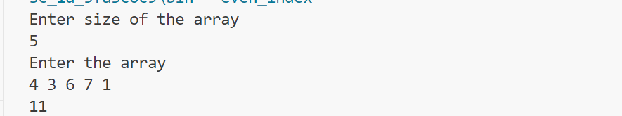

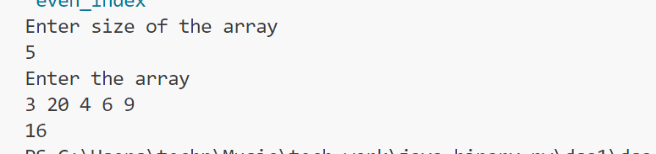

**Q2: Write a program to traverse over the elements of the array using for each loop and print all even**

**elements.**

**Input 1: arr[] = {34,21,54,65,43}**

**Output 1: 34 54**

**Input 1: arr[] = {4,3,6,7,1}**

**Output 1: 4 6**

**Code:**

**import java.util.Scanner;**

**public class even_element {**

**public static void even_element_print(int arr[] ){**

**for(int i:arr){**

**if (i%2==0) {**

**System.out.println(i);**

**}**

**}**

**}**

**public static void main(String[] args) {**

**Scanner sc = new Scanner(System.in);**

**System.out.println("Enter size of the array");**

**int m = sc.nextInt();**

**System.out.println("Enter the array ");**

**int arr[] = new int [m];**

**for(int i=0;i<=m-1;i++)**

**{**

**arr[i]= sc.nextInt();**

**}**

**even_element_print(arr);**

**}**

**}**

**Output:**

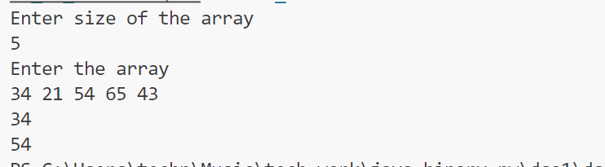

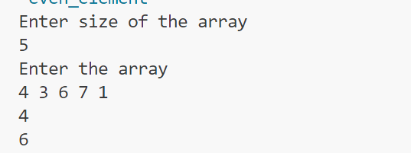

**Q3: Write a program to calculate the maximum element in the array.**

**Input 1: arr[] = {34,21,54,65,43}**

**Output 1: 65**

**Input 1: arr[] = {4,3,6,7,1}**

**Output 1: 7**

**Code:**

**import java.lang.reflect.Array;**

**import java.util.Arrays;**

**import java.util.Scanner;**

**public class max_element {**

**public static void max_element_print(int arr[]){**

**Arrays.sort(arr);**

**System.out.println(arr[arr.length-1]);**

**}**

**public static void main(String[] args) {**

**Scanner sc = new Scanner(System.in);**

**System.out.println("Enter size of the array");**

**int m = sc.nextInt();**

**System.out.println("Enter the array ");**

**int arr[] = new int [m];**

**for(int i=0;i<=m-1;i++)**

**{**

**arr[i]= sc.nextInt();**

**}**

**max_element_print(arr);**

**}**

**}**

**Output:**

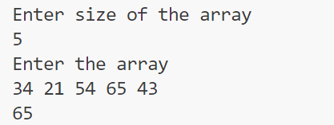

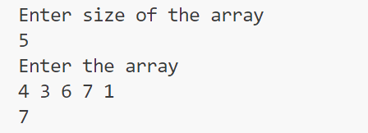

**Q4: Write a program to find out the second largest element in a given array.**

**Input 1: arr[] = {34,21,54,65,43}**

**Output 1: 54**

**Input 1: arr[] = {4,3,6,7,1}**

**Output 1: 6**

**Code:**

**import java.util.Arrays;**

**import java.util.Scanner;**

**public class second_max_element {**

**public static void second_max_element_print(int arr[]){**

**Arrays.sort(arr);**

**System.out.println(arr[arr.length-2]);**

**}**

**public static void main(String[] args) {**

**Scanner sc = new Scanner(System.in);**

**System.out.println("Enter size of the array");**

**int m = sc.nextInt();**

**System.out.println("Enter the array ");**

**int arr[] = new int [m];**

**for(int i=0;i<=m-1;i++)**

**{**

**arr[i]= sc.nextInt();**

**}**

**second_max_element_print(arr);**

**}**

**}**

**Output:**

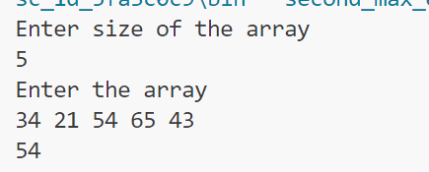

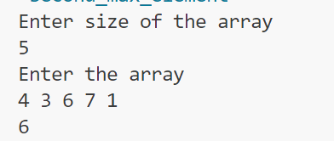

**Q5: Given an array. Find the first peak element in the array. A peak element is an element that is greater than**

**its just left and just right neighbor.**

**Input 1: arr[] = {1,3,2,6,5}**

**Output 1: 6**

**Input 2: arr[] = {1 4,7,3,2,6,5}**

**Output 1: 7**

**Code:**

**public class peak_element {**

**public static int findFirstPeak(int[] arr) {**

**int n = arr.length;**

**// Check for the first peak element**

**for (int i = 1; i < n - 1; i++) {**

**if (arr[i] > arr[i - 1] && arr[i] > arr[i + 1]) {**

**return arr[i];**

**}**

**}**

**return -1;**

**}**

**public static void main(String[] args) {**

**int[] arr1 = {1, 3, 2, 6, 5};**

**int[] arr2 = {1, 4, 7, 3, 2, 6, 5};**

**System.out.println("First peak in arr1: " + findFirstPeak(arr1));**

**System.out.println("First peak in arr2: " + findFirstPeak(arr2));**

**}**

**}**

